Creating a Simulation object:

1. Launch the Simulation Editor

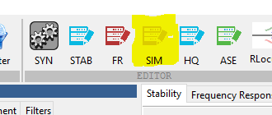

1. The Simulation object editor will appear on the screen.

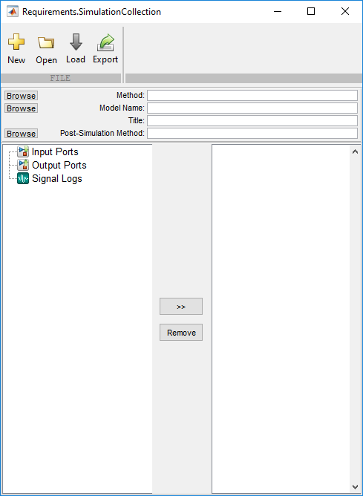

1. Browse to the “Method”. Must be a Matlab file(.m). See “…\Aerion\Direct Mode Design - GS\Methods\Simulation\simModel.m” for an example of how to set up the script.



1. Browse to the Simulink model.



1. Add a title to the Simulation Object by typing in the box. ( This wiill appear in the project tree)



1. Optional – Add a “Post-Simulation Method”



1. Select signals from the Simulation to see the time history plots. ( One signal per Plot). At this time you may only select up to 16 signals.

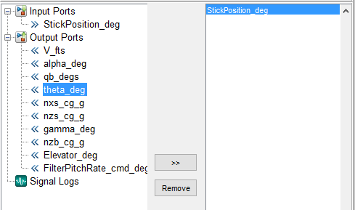

1. To add a signal - highlight the signal on the left side menu and press the “>>” button.

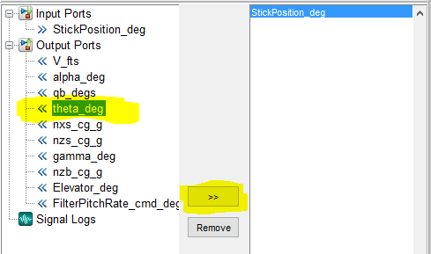

1. To remove a signal – Highlight a signal from the right side and press the “Remove” button.

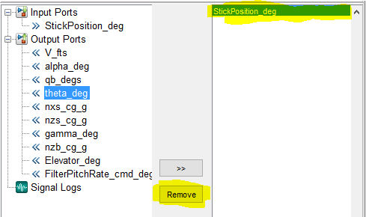

1. Save the project to a “.mat” file using the “Export” button.

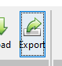

1. Choose a location to save the file.
2. Inside the Project tree – You may remove any unnecessary existing Simulation objects in 2 ways.
   1. Remove All – Right Click the Simulation node.

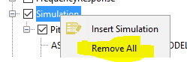

* 1. Remove – Removes only the selected Simulation object. To do this right click on the Simulation object that you would like to remove and choose “Remove”.

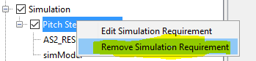

1. Inside the Project tree – right click on the Simulation node and choose “Insert Simulation”.

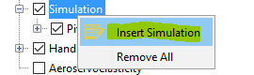

1. Browse to the .mat file that contains the Simulation object you saved in step 9.

